KS3 WIDER COMMUNICATION

ACTIVITY 4

Here is a quotation from Dylan Thomas’s Timeline:

1982: Plaque to Dylan unveiled in Poets’ Corner, Westminster Abbey

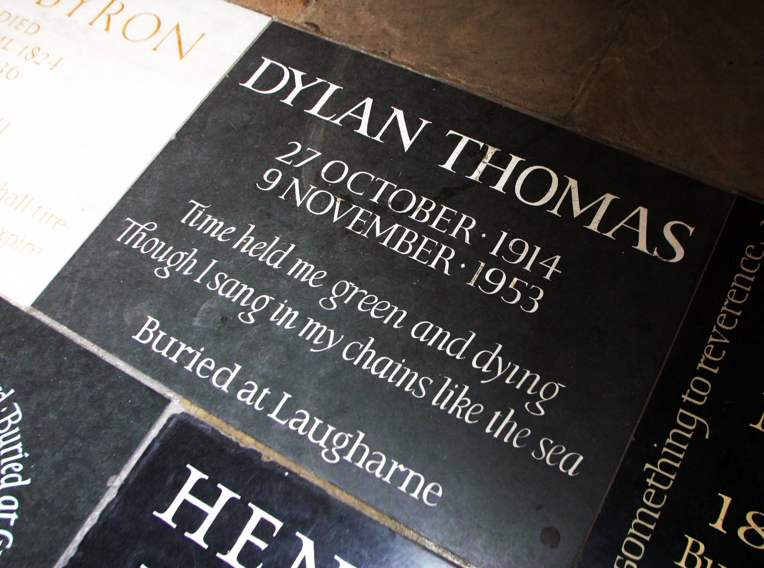

Some discussion points:

- Why do you think it took nearly 50 years for Dylan Thomas to gain a place in Poets’ Corner?

- Is it important to be recognised beyond one’s own area/country?
- Choose a favourite quotation by your favourite poet/songwriter.

